# ITEC 2905 Artificial Intelligence Lab

**You must be in class and work in a team to receive credit for this lab.**

For this lab you will investigate how well artificial intelligence (AI) tools generate code.

You will work in a team of 4 and investigate one AI tool each. If your team has fewer people, then pick one AI tool each and skip the other tool(s).

Either upload this document to OneDrive or Google Docs and collaborate on it; or one person can fill in the document and share with the rest of the team at the end of class.

You will need to insert screenshots into this document. You can share screenshots by pasting them into the Zoom chat, then clicking on them to download to your computer.

You will work with these AI tools. Each person on your team will work with one of these tools.

* ChatGPT <https://chatgpt.com/>
* MetaAI <https://www.meta.ai/>
* Copilot <https://copilot.microsoft.com/>
* Gemini <https://gemini.google.com/>

**Part 1 Team member names, StarIDs, AI tool chosen**

|  |  |  |
| --- | --- | --- |
| **Name** | **StarID** | **AI tool** |
| Alessandro C. | ci6117or | Google Gemini |
| Mike McElhiney | jy7655iu | Microsoft Copilot |
| Wolid Kamal | yv5378rd | ChatGPT |
|  |  |  |

**Part 2 Each person: complete a short quiz about your opinions on AI tools. Check the Quiz section of D2L.**

The instructor will provide the quiz password in class.

This is a screenshot of the questions you’ll be asked. This is a survey so there are no wrong answers. Choose the answers that align best with how you feel.

**Part 3 Generating code for a class assignment**

Read this question from a lab set in ITEC 1150 and consider the code you would write to solve it. At this point in the semester, ITEC 1150 students would have covered string, int and float variables; input; printing. They would have not covered f-strings.

Each person: ask your AI tool to solve this problem.

*2.****Travel Expenses*** *Write a program that calculates the amount of money spent on bus fares last month.*

*For this problem, you can ignore transfers, and rush-hour fares, and assume every bus ride costs the same.*

* *Ask the user for the number of times they rode the bus last month (what data type do you need to convert the input to?) and save in a variable.*
* *Ask the user for the cost of one bus ride (what data type do you need to convert the input to?) and save in another variable.*
* *Calculate the total cost of riding the bus last month. Multiply the two variables and store the result in a new variable.*
* *Print one line that includes the number of rides, the cost of one bus ride, and the total cost for the user. Use the method shown in the videos to join together the text and variables, converting numeric variables to strings as needed.*

*Example output would look like this:  'You rode the bus 8 times last month. One bus ride costs $2. Your total cost was $16'*

*or 'You rode the bus 3 times last month. One bus ride costs $1.75. Your total cost was $5.25'*

**Insert screenshots of each AI tool’s response.**

**ChatGPT Screenshot**

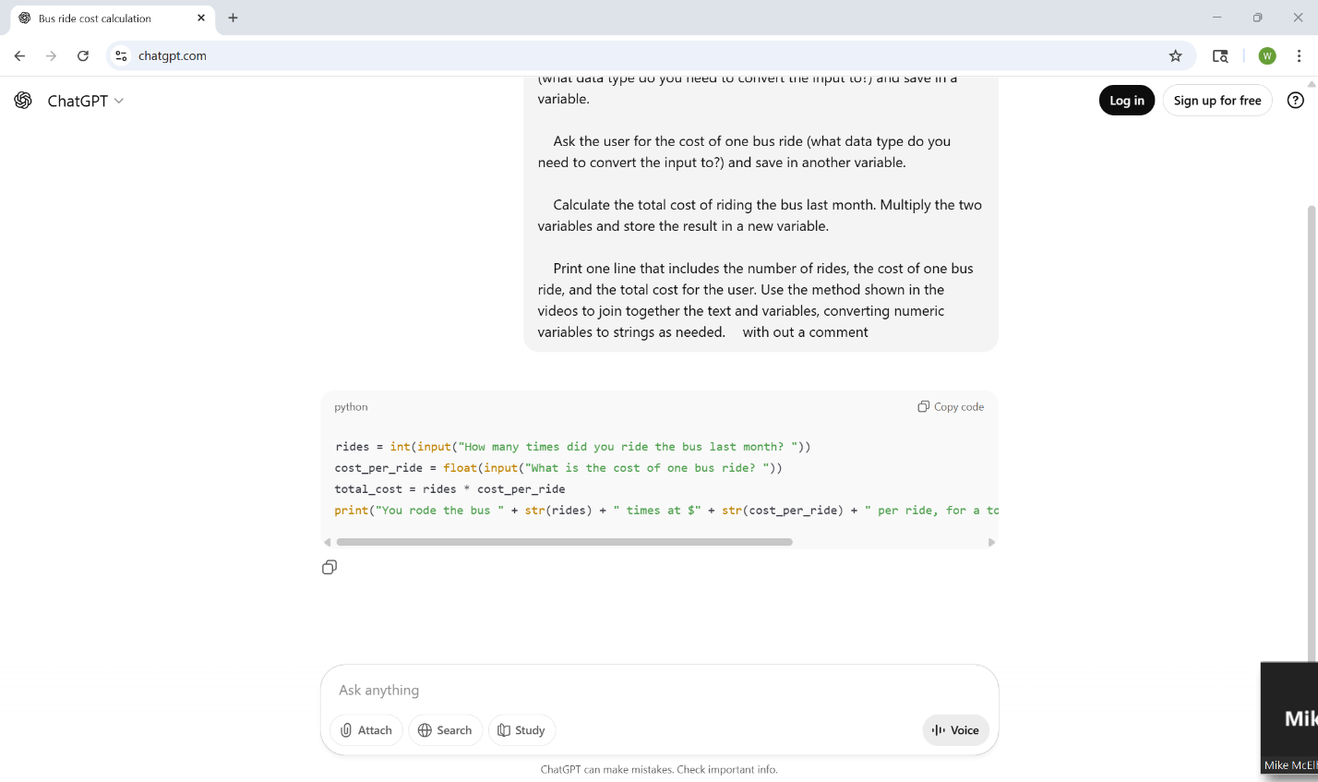

**Copilot Screenshot**

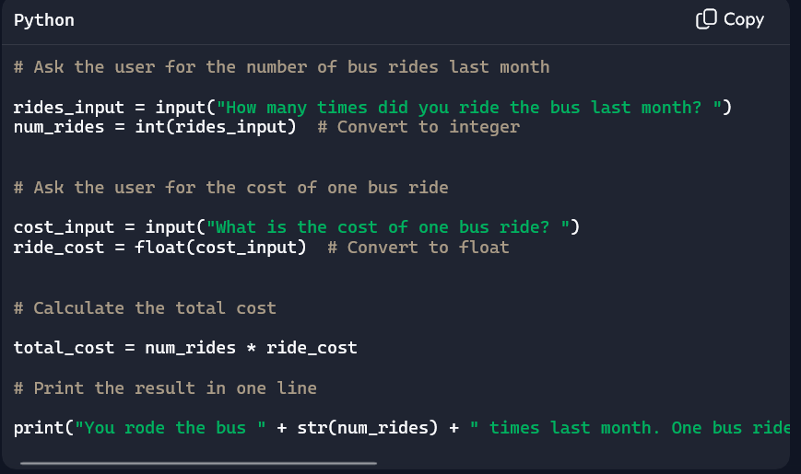

**Gemini Screenshot**

**MetaAI Screenshot**

Read the AI tool's response. How does it compare to your human-generated solution? How appropriate is the response for a student in ITEC 1150?

Did the AI tools solve the assignment correctly? Review the output, and check for the following things. What did they get right, and what did they get wrong?

* Wrote Python code
* Asked for the number of rides and converted to an int
* Asked for the price of one ride and converted to a float
* Did the correct math to calculate the total
* Converted number data types to strings and concatenated to print the output, **NOT f-strings**
* Printed all the output on one line, NOT multiple lines
* Added comments to the code
* Did the AI tool add anything extra to the code? Functions, exception handling?

**Fill in this table**

|  |  |
| --- | --- |
| **AI Tool** | **Did the AI tool solve the assignment completely and correctly? Describe what was not complete or not correct** |
| ChatGPT | I see the code is written correctly but the formattly i little bit different. |
| Copilot | Copilot accomplished the task surprisingly well and it even looks like beginner code to me. One thing I noticed is that it rounded the float to 1 decimal space and it should be 2 because its dollar amounts. |
| Gemini | Google Gemini correctly added every feature for the bus fare program correctly. Comments were properly included to explain the code, and the total cost output consists of all four digits in the float number when performing the math. I believe a feature Gemini added was printing a “Invalid input” message, but it doesn’t loop back to the question and just exits the program. |
| MetaAI |  |

**Part 4 Generating code for a program that uses an API**

Each person, use your AI tool to generate Python code for this problem. It is possible to write a working solution to this problem.

*Write a program to connect to this API that mimics the behavior of a Magic 8 Ball (*[*https://en.wikipedia.org/wiki/Magic_8_Ball*](https://en.wikipedia.org/wiki/Magic_8_Ball)*). The program should let the user ask a question, and it will print the Magic 8 Ball’s response to that question. The API home page is* [*https://magic-8-ball-mctc.uc.r.appspot.com/*](https://magic-8-ball-mctc.uc.r.appspot.com/)

**Try the code it generates in PyCharm. Does it work?  If the AI tool describes what the program does, is the AI description accurate?**

**Insert screenshots of each AI tool’s response.**

**ChatGPT Screenshot**

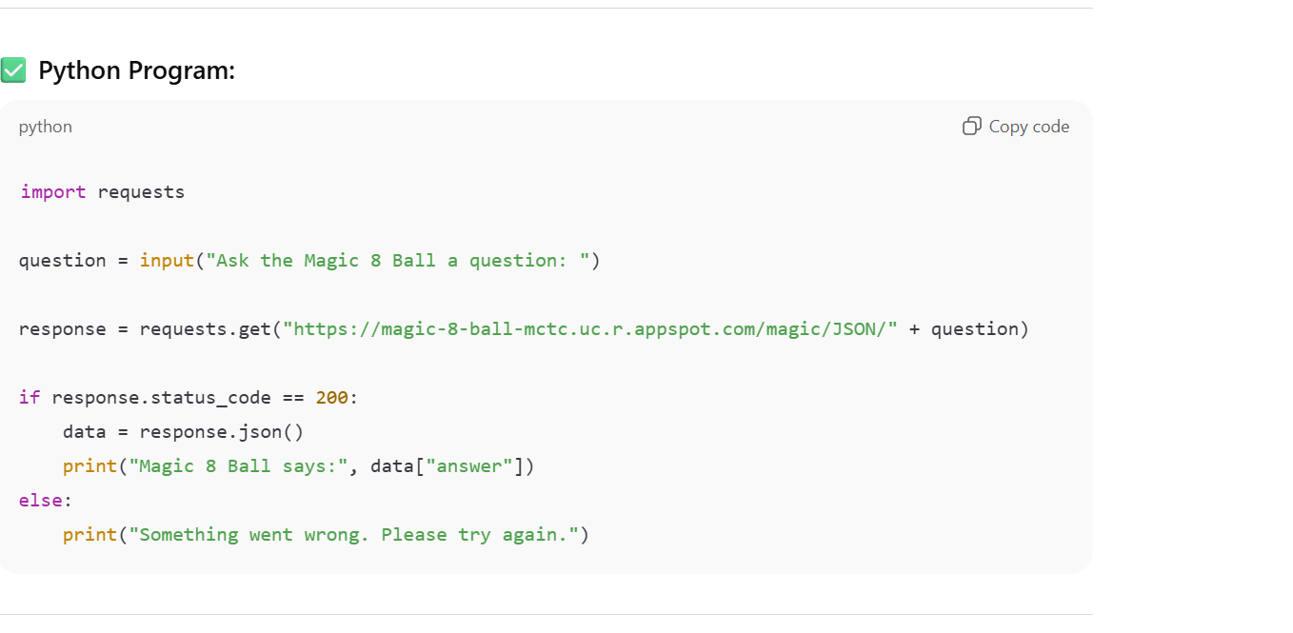

**Copilot Screenshot**

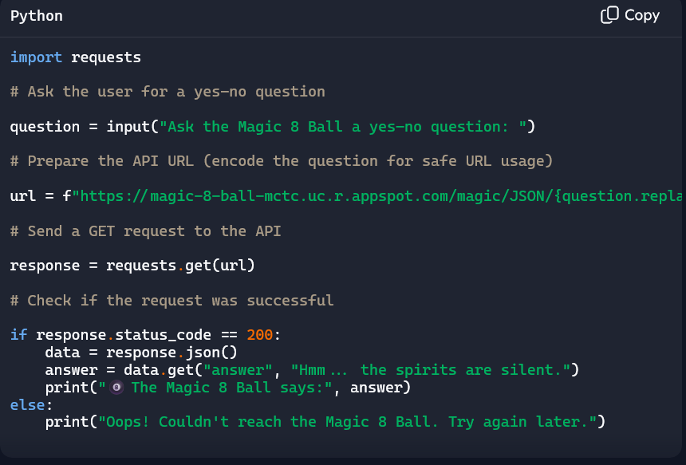

**Gemini Screenshot**

**MetaAI Screenshot**

**If you see errors, can the AI tool help you fix them? Tell it about the errors and try the suggested solutions.**

**Were you able to get the program running? It's ok if you can't. The goal for this question is to try AI generated code.**

**Fill in this table**

|  |  |
| --- | --- |
| **AI Tool** | **Did the AI tool solve the assignment completely and correctly? Describe what was not complete or not correct** |
| ChatGPT | It is just trying to add some response and code to make the code works but it is not working. Trying to add miss information to the code. |
| Copilot | Not exactly. It does get a response from the API but it's not displaying it properly. It's only displaying the message for if it does not receive a response even though it is in fact receiving a response. I know it’s getting a response because I asked the AI to fix it and created new code that displays whatever the json response is from the API so when I run it, it displays a legit response from the API but still shows the ‘no response’ message. |
| Gemini | Gemini produced code that seemed correct on paper, but after running the code repeatedly, I could not get a response from the Magic 8 ball. Gemini is baffled about the API not responding correctly and is struggling to understand the JSON response from the server. |
| MetaAI |  |

**Insert screenshots of the code running; or if it doesn’t run correctly, screenshots of any error(s) you see.**

**ChatGPT Code Screenshot**

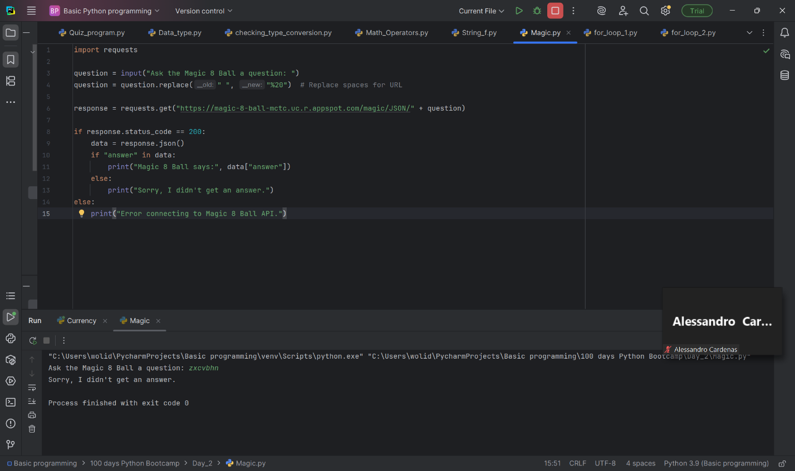

**Copilot Code Screenshot**

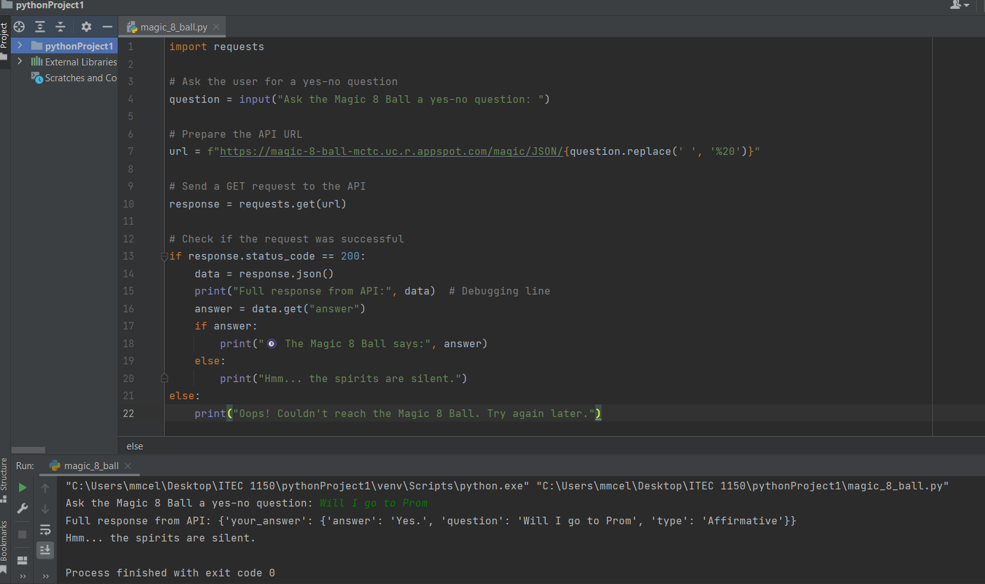

**Gemini Code Screenshot**

**MetaAI Code Screenshot**

**Part 5 Each person: complete a short quiz about your current opinions on AI tools. Check the Quiz section of D2L.**

The instructor will provide the quiz password in class.

You’ll be asked the same questions in the first quiz, plus a question asking if your feelings have changed or stayed the same, or why. This is a survey so there are no wrong answers. Choose the answers that align best with how you feel.

Share this document with your team. **Everyone must upload a copy to D2L to receive credit for this lab.**